Joseph Thimote
CS 210: Programming Languages
Project Three: Corner Grocer Item-Tracking Program
June 21, 2026
Functional Design Document
The Corner Grocer’s Item Tracker application uses the data from daily produce purchase transactions to determine optimal store displays. The core of this application is the GroceryTracker Class that will use a map to both keep track of, as well as manipulate, item frequency information. The main() function of the application creates and initalizes a GroceryTracker object with specified source and backup file names. Following initialization, it calls upon the groceryTrackerMenu() function to provide an interactive menu for the user. This interactive menu remains available until the user chooses to exit the application.

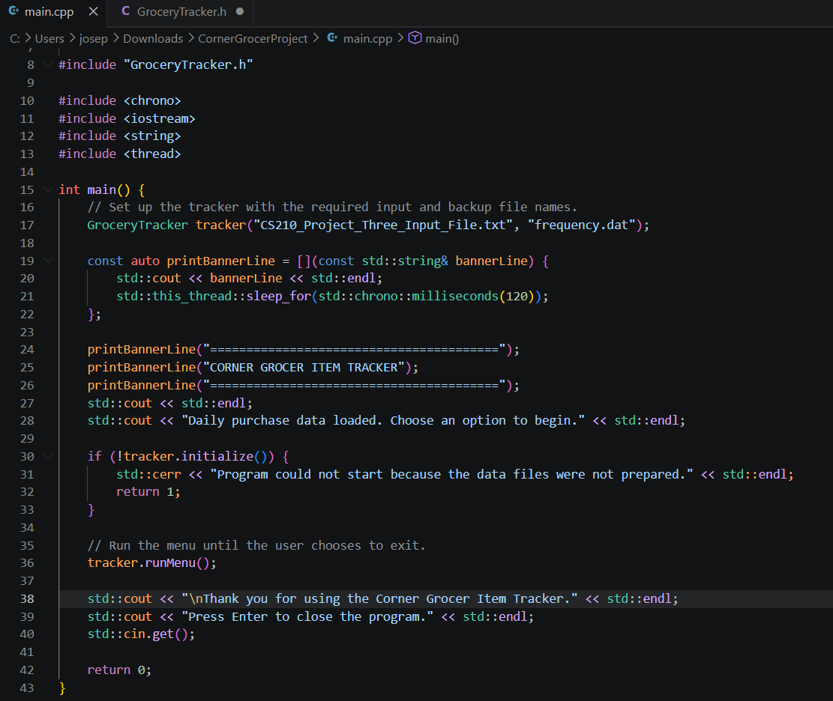
Figure 1. Program entry point in main.cpp: the GroceryTracker object is created and the menu is run.
The GroceryTracker class uses private members, such as the itemFrequencies std::map, to represent data while exposing essential behaviors via a public interface. As shown in Figure 2, the class includes a constructor, an initialize method, and getFrequencyForItem, which handles Menu Option 1 by returning an item's count or zero if it is not found.
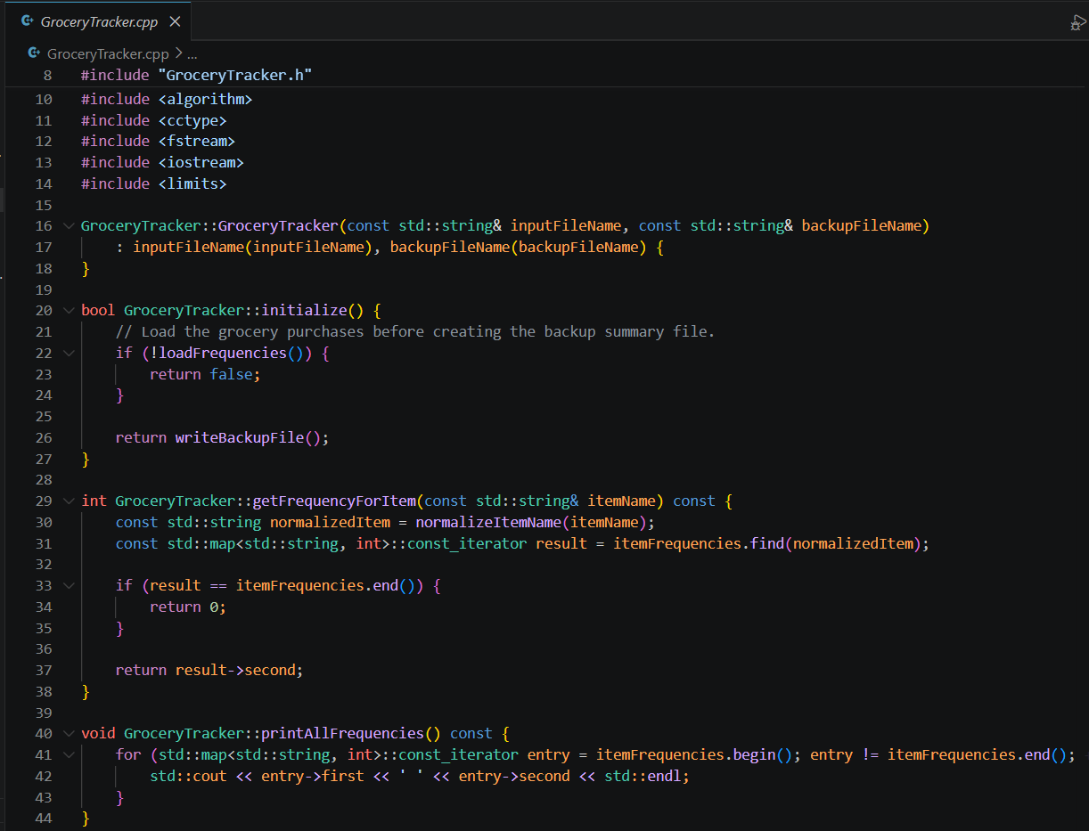
Figure 2. Constructor, initialize, and the getFrequencyForItem lookup in GroceryTracker.cpp.
A std::map is used to automatically store unique items in sorted order. As illustrated in Figure 3, loadFrequencies increases item counts using ++itemFrequencies[normalizeItemName(currentItem)], initializing new items at zero. writeBackupFile automatically generates frequency.dat upon startup, making sure all counts are saved without user intervention.
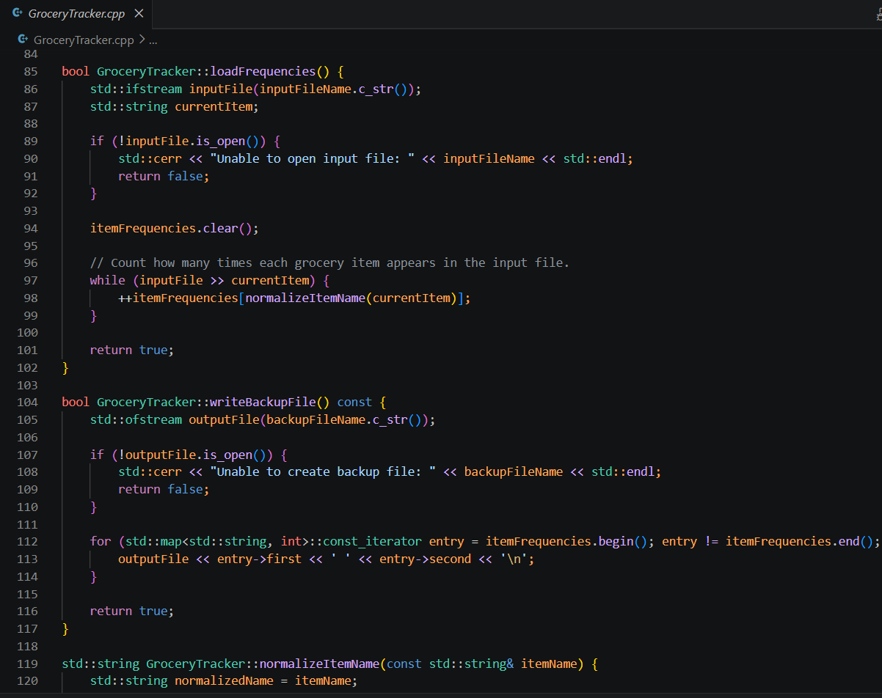
Figure 3. Counting items with a std::map in loadFrequencies and writing the frequency.dat backup in writeBackupFile.
Figure 4 illustrates the final menu functions. The printHistogram method fulfills Menu Option 3 by outputting item names alongside asterisks representing purchase count totals. The runMenu method manages program execution: it presents the menu, processes user input via a switch statement, and then terminates once option four is selected.
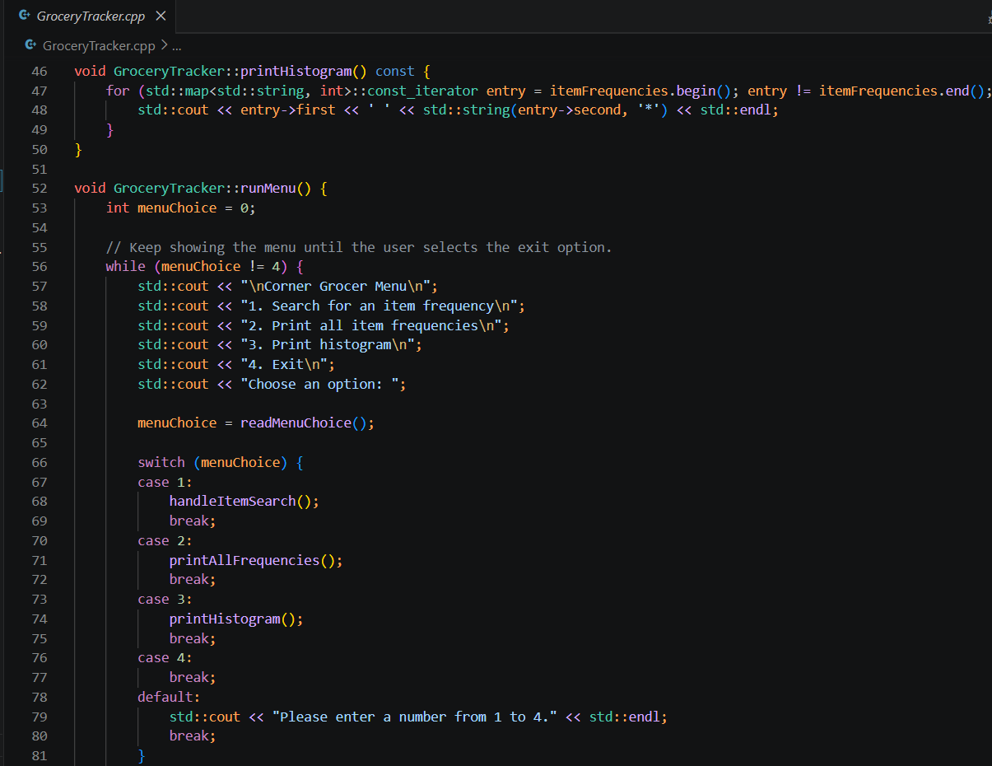
Figure 4. The printHistogram output and the runMenu loop with switch based routing in GroceryTracker.cpp.
Figure 5 highlights helper methods, including readMenuChoice for input validation and handleItemSearch for processing search terms. Industry-standard naming and commenting ensure the codebase remains clear and maintainable.
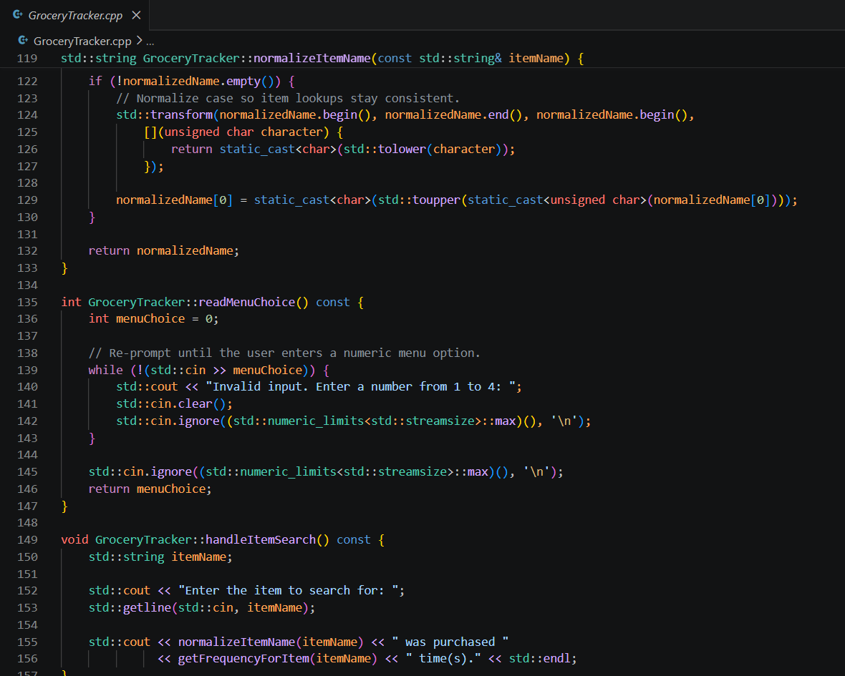
Figure 5. Input validation in readMenuChoice and the item search in handleItemSearch

